Devin Hom
Patricia Williamson
Environmental Science
12 December 2015

Biodiversity Final Project: Public Waterfront Promenade v. Veterans Memorial Park
Research
The two communities I chose to research were the Public Waterfront Promenade and Veterans Memorial Park. Within these locations, there are small muddy, marsh- like areas that seems to be home to many small organisms much like the shores of Crab Cove. Although they are quite close together, the two are different when it comes to their location in the San Francisco Bay. The Memorial Park, which is on Bay Farm, is closer to the main part of the bay while the Waterfront Promenade, a part of the main island, is more inland. The other possible difference between the two locations is the amount of traffic each gets. The Veterans Memorial Park is just off of a major street in Bay Farm, therefore making it readily accessible. In the case of the Public Waterfront Promenade, it is much more secluded since it is tucked behind Lincoln Middle School.
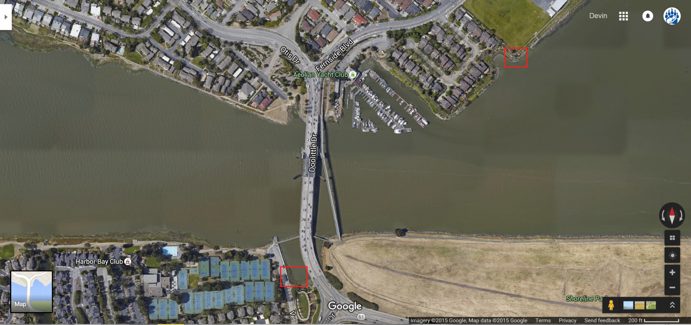
_____________________________________________________________________________________
Hypothesis
Since the Public Waterfront Promenade is more inland than the Veterans Memorial Park, and therefore has more protection from natural forces, it will show more richness and in turn, have a higher biodiversity.
_____________________________________________________________________________________
Procedure

Create the Biodiversity Quadrant
- Obtain four PVC pipes (size and thickness may vary) and four PVC corners with the same width.
- Using the pieces listed above, construct a square that will act as a border signaling a designated area.

Measuring Biodiversity
- Place the biodiversity quadrant down on a random area within the chosen location.
- Within the square, record each organism that is present.
- Repeat steps 1 and 2 until three plots are measured within the location.
- Repeat steps 1-3 for the other location for comparison.

_____________________________________________________________________________________
Data & Analysis

Waterfront Promenade’s Average Biodiversity Index: 2.28

Plot 1
Name of Organism | Number (n) | n(n-1)
Beach Hopper | 25 | 600
Rock Louse | 8 | 56
Pickleweed | 1 | 0
Littleneck clam | 1 | 0

35(34)/565= 2.1

Plot 2
Name of Organism | Number (n) | n(n-1)
Beach Hopper | 9 | 72
Rock Louse | 3 | 6
Pickleweed | 1 | 0
Ice plant | 1 | 0

14(13)/78= 2.3

Plot 3
Name of Organism | Number (n) | n(n-1)
Beach Hopper | 17 | 272
Rock Louse | 12 | 132
California Mussel | 1 | 0
Pickleweed | 1 | 0
Ice Plant | 1 | 0

32(31)/404=2.45
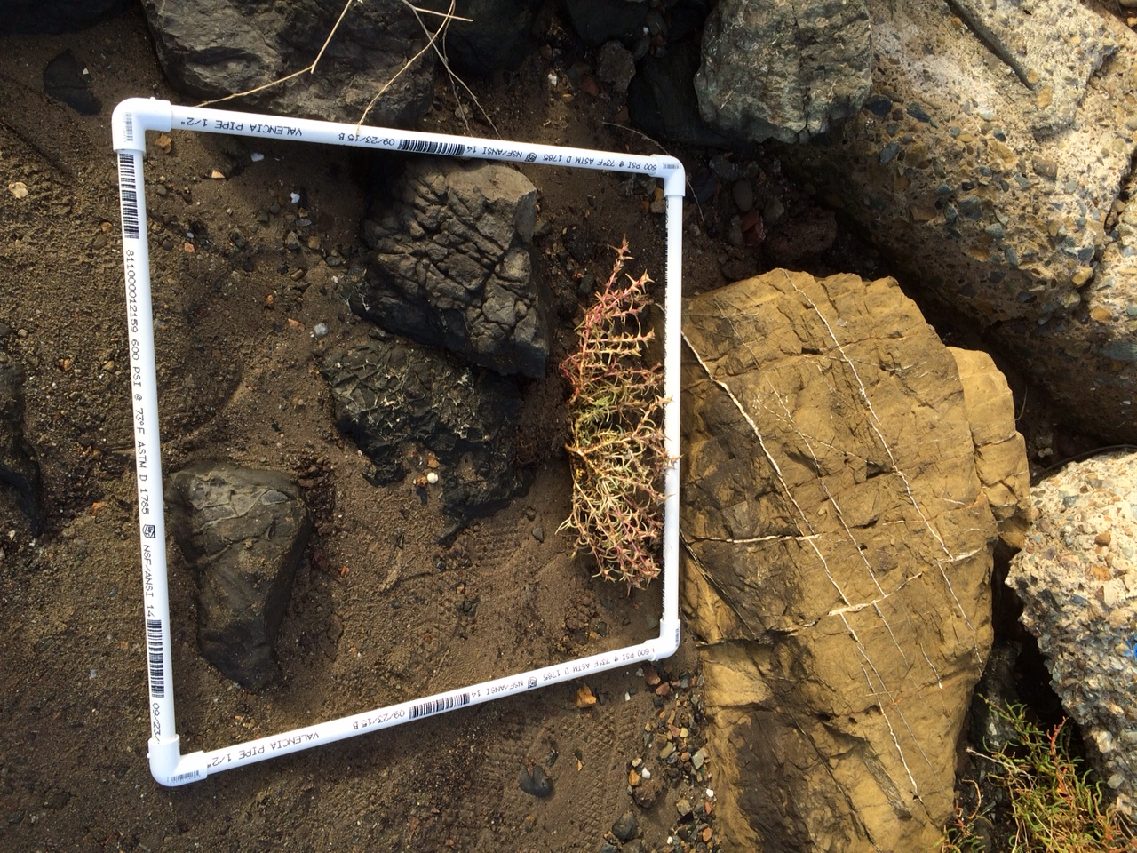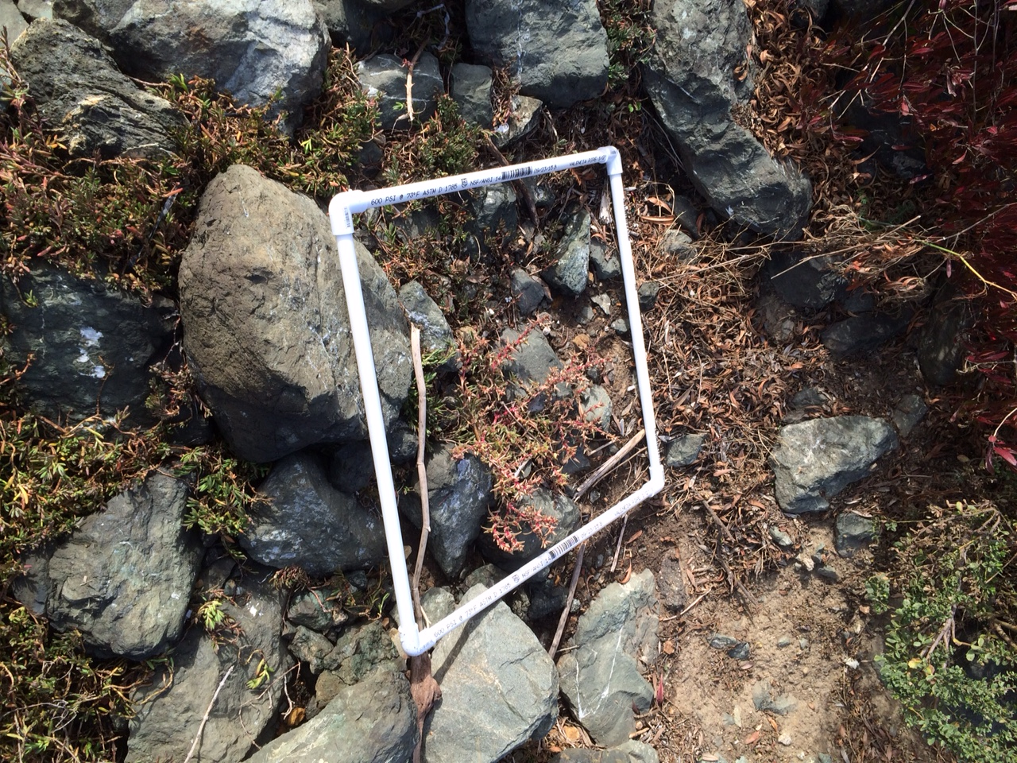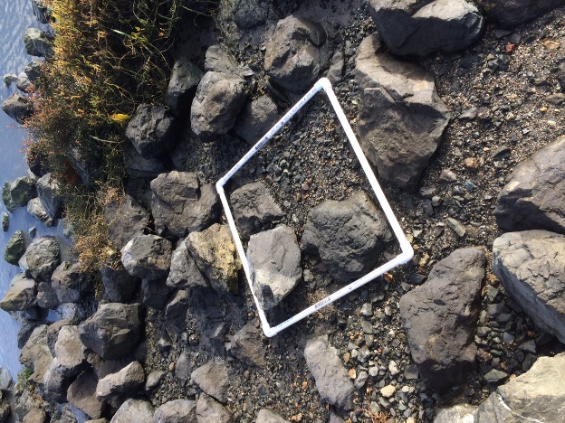

Veterans Memorial Park’s Average Biodiversity Index: 1.29

Plot 1
Name of Organism | Number (n) | n(n-1)
Sea Lettuce | 5% | -
Pill Bug | 17 | 272
Unidentified clam | 2 | 2

19(18)/274=1.25

Plot 2
Name of Organism | Number (n) | n(n-1)
Sea Lettuce | 20% | -
Pill Bug | 32 | 992
Unidentified Clam | 1 | 0

33(32)/992=1.06

Plot 3
Name of Organism | Number (n) | n(n-1)
Sea Lettuce | 5% | -
Barnacles | 36 | 1260
Pill Bug | 9 | 72
Unidentified Clam | 1 | 0

46(45)/1332=1.55
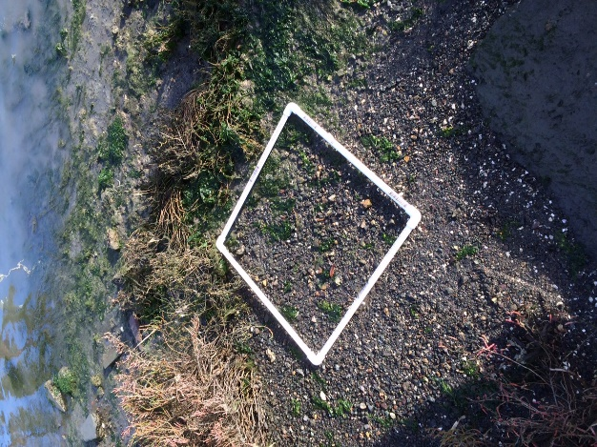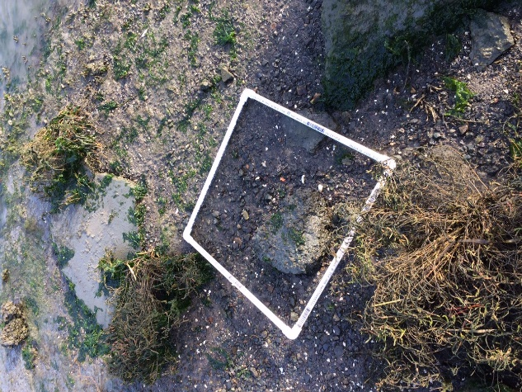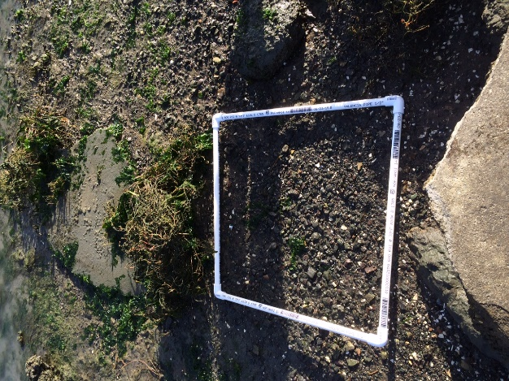

Conclusion
Based on the results, the hypothesis that the Waterfront Promenade is more biodiverse than the Veterans Memorial Park was supported. With an average biodiversity index of 2.28, the Waterfront Promenade was obviously more diverse than the Memorial Park, with its average of only 1.29. The main factor that contributed to its higher biodiversity has to do with the richness of the environment. In the Memorial Park, the maximum amount of species found that could be entered accounted for in the Simpson’s Index was three. In the case of the Waterfront Promenade, the highest amount of species recorded was five. In addition to richness, the fact that there were single plants found in the Waterfront Promenade made it so nothing would be added to the denominator of the index, while more would be added to the numerator, resulting in the bigger number. The Waterfront Promenade has the highest biodiversity most likely because it is further inland and also because it may be less visited and therefore less disturbed by traffic.

